**Summary for COVID-19 Internal Dashboard – Team 2**

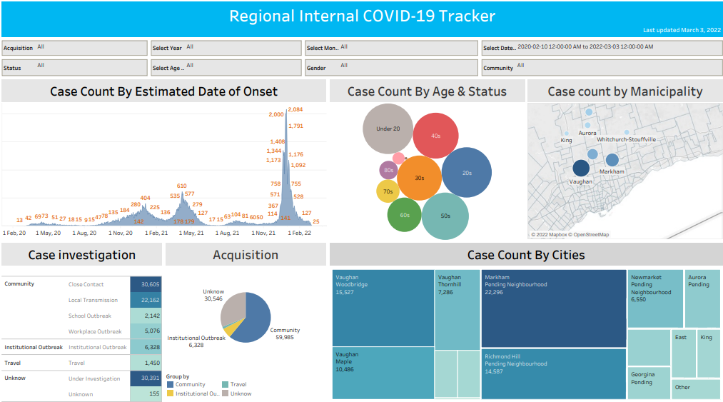

**Client**

region’s COVID response team

**Goal**

This pandemic tracker board helps internal resource assignment

**Key insights**

* quick drop during 2022 Jan - early March 3
* transmission channel is mainly by community close contact
* major infected group: 20s and under
* main deceased group: 70s and above by institutional outbreak
* high volume of spread cases in Vaughan city, specially in its community called Woodbridge, Maple and Thornhill

**Remark**

* Onset date vs Reported date
* Time frame 2020 Feb 10 – 2022 March 3 (Null & 1987)
* Further investigation needed (unknow in case investigation)